41.42: a) The energy shift from zero field is 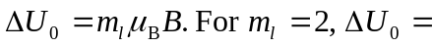
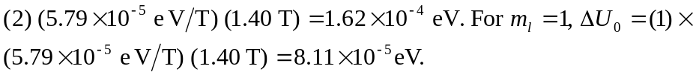
b) 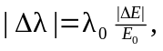 where
Then, 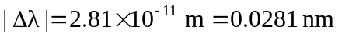. The wavelength corresponds to a larger energy change, and so the wavelength is smaller.

